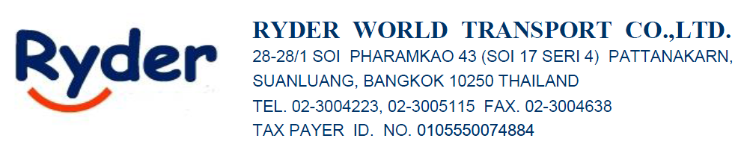15/6/26

ATTN : K.MUT

FROM : Sirisak Srisuwan (Sam) 065-625-4945

FREIGHT RATE QUOTATION (IMPORT-LCL) EX-Work

Port/Country | Ocean Freight | CLS  CLOSING EXPORT ENTRY & VGM WITHIN FRIDAY | ETD | T/T
Port/Country | LCL | CLS  CLOSING EXPORT ENTRY & VGM WITHIN FRIDAY | ETD | T/T
NINGBO | $35/CBM | MON/TUE/THU | FRI/SAT/MON | 10 DAYS

LOCALCHARGE IN BKK
CFS : THB550/RT
THC : THB550/RT
STS : THB200/RT
FAC : THB150/RT
D/O : THB1,500/SET
HANDLING : THB 500/SET

LOCALCHARGE EX-WORK IN CHINA
EBS+CIC : USD 20/RT
DOC : USD 45/SET
CUSTOM CLEARANCE : USD 40/SET
PICK UP CHARGE : USD 120/TRUCK
H/C : USD 20/SET

*Remake*
Please note that items not specified here do not cover actual expenses billed according to receipts, nor do they include VAT.

Best Regards,
Sirisak Srisuwan (Sam)
Sales
Ryder World Transport Co., Ltd.
28-28/1 Soi Pharamkao 43 (Soi 17 Seri 4)
Pattanakarn, Suanluang, Bangkok 10250 THAILAND
Tel: (662)300 4223, (662)300 5115 (Ext. 215)
Mobile: (66)65-625-4945
Fax: (662)300 5092
Website: www.ryder.co.th

